TOWN OF NOKOMIS

NOKOMIS LAND DIVISION AND SUBDIVISION CONTROL ORDINANCE

ORDINANCE No. 07-26

The Town Board of the Town of Nokomis, Wisconsin intending to amend the existing Town of Nokomis Subdivision Ordinance does ordain as follows:

SECTION 1

TITLE/NAME - This Ordinance shall be known and cited as The Nokomis Land Division and Subdivision Control Ordinance.

SECTION 2
AUTHORITY - This Ordinance was adopted under the statutory authority granted pursuant to the Powers of the Town of Nokomis, and all applicable Wisconsin State Statutes.

SECTION 3

PURPOSE - The purpose of this Ordinance is to regulate and control the division of land within the limits of the Town of Nokomis, Oneida County, Wisconsin, in order to accomplish all of the following purposes:
- Promote the public health, safety, morals, prosperity, aesthetics and general welfare of the Town.
- Supplementing County, State, and Federal land division controls to implement any Town Comprehensive plan, master plan, or other land use plans.
- Promoting the planned and orderly layout and use of the land in the Town.
- Encouraging the most appropriate use of the land through the Town.
- Minimizing the public impact resulting from the division of large tracts into smaller parcels of land in the Town.
- Facilitating the adequate provision of transportation, water, sewage, health, education, recreation, and other public requirements in the Town.
- Providing the best possible environment for human habitation in the Town.
- Enforcing the goals and policies set forth in any Town Comprehensive Plan, master plan, or other land use plans.
- Ensuring that the design of the street system will not have a negative long-term effect on neighborhood quality, traffic flow, and safety in the Town.
- Realizing goals, objectives, policies, and development standards set forth in plans, codes, and ordinances adopted by the Town.
- Securing safety from fire, flooding, and other dangers in the Town.
- Avoiding the inefficient and uneconomical extension of governmental services in the Town.
- Conserving the value of prime agricultural soils in the Town of .
- Providing for the conservation of the agriculturally important lands in the Town.
by minimizing conflicting land uses.
- Promoting the rural and agricultural character, scenic vistas, and natural beauty of the Town
- Regulate the development of condominium projects.
- Insure accurate legal descriptions.
- Providing for administration and enforcement of this Ordinance by the Town Board.

SECTION 4

INTERPRETATION - In its interpretation and application, the provisions of this Ordinance shall be held to be minimum requirements and shall be liberally construed in favor of the Town and shall not be deemed a limitation or repeal of any other power granted by the Wisconsin Statutes to the Town.

SECTION 5

DEFINITIONS – The following definitions shall apply and control this Ordinance. Words or phrases not defined specifically below, but used in this Ordinance, shall be interpreted so as to give them the same meaning as they have at common law and to give this Ordinance its reasonable application.
Arterial Street: A street used or intended to be used primarily for fast or heavy through traffic. Arterial streets shall include freeways, highways and expressways as well as standard arterial streets, highways and parkways.

Building Setback Line: A line within a lot or other parcel of land so designated on a preliminary plat which denotes the area between such line and the adjacent street right-of-way line or adjacent lot line where an enclosed building and other obstructions are prohibited, except those obstructions that are permitted by zoning ordinance regulations.

Certified Survey Map (CSM): A map of a division of land prepared in accordance with Wis. Stat. §236.34 and in full compliance with the applicable provisions of this Ordinance.
Collector Street: A street used or intended to be used to carry traffic from Town roads to major arterial streets, including the principal entrance streets to residential developments.

Condominium: A building or a group of buildings in which units are owned individually and the building common areas and facilities are owned by all owners on a proportional undivided basis. A condominium is a legal form of ownership and not a specific building type or style.

County: Oneida County, unless a general reference to counties is inferred.

Cul-De-Sac: Town roads with only one (1) outlet and having an appropriate turnaround for the safe and convenient reversal of traffic, snow plowing and fire protection equipment.

Deed Restriction: a restriction on the use of a property set forth in a deed or other instrument of conveyance, including, but not limited to, a restrictive covenant, conservation easement, transfer of development rights, or any restriction placed on undeveloped land as a condition for the division or development of the undeveloped land.

Development: The act of dividing land, constructing buildings or installing site improvements.

Drainage Right-Of-Way: The lands require for the installation of storm water sewage or drainage ditches. They are required along a natural stream or water course for preserving the channel and providing for the flow of water therein to safeguard the public against flood damage.

Dwelling: A structure or part of a structure used or intended to be used as a home, residence, or sleeping place by one or more persons.

Easement: Any land reserved for public utilities, access, drainage, sanitation or other specified uses having limitations, the title to which shall remain in the property owner, subject to the right of use designated.

Final Plat: The map of record of subdivision and any accompanying materials that is in accordance with requirements of Chapter 236 of the Wisconsin Statutes and this Ordinance. A Final Plat precisely describes the location and exterior boundaries of the parcel to be divided and shows the precise location of lots and other improvements.

Floodplain: The land that has been or may hereafter be covered by floodwater during a regional flood. The floodplain is comprised of the floodway and flow fringe and general floodplain areas as delineated on the FEMA maps.

Frontage: The length of the front property line of the lot (s) or tract of land abutting a public street, road, highway or public right-of-way.
Land Division: The division of a lot, outlot, parcel, or tract of land into two or more smaller parcels for the purpose of transfer of ownership or building development or other intended uses of the land.

Land Improvement: Any sanitary sewage system, storm sewer system, water supply and distribution system, roadway, terrace, trail, pedestrian way, no-access strip, off-street parking area or other improvements which the Town requires under this ordinance.

Lot: A portion of a subdivision or other parcel of land which may be intended for transfer of ownership or for building development.

Lot Frontage: That side of a lot abutting on a public street right-of-way and ordinarily regarded as the front of the lot.

Ordinary High-Water Mark (OHWM): The point on the bank or shore up to which the presence and action of surface water is so continuous as to leave a distinctive mark such as by erosion, destruction or prevention of terrestrial vegetation, predominance of aquatic vegetation, or other easily recognized characteristic.

Outlot: A parcel of land other than a lot or block intended for transfer of ownership, dedication or for use of a private right-of-way. An outlot may not be used as a building site unless it is in compliance with restrictions imposed under this Chapter with respect to building sites. An outlot may
be the site of a private road, a non-buildable parcel having poor soils or topographic conditions or a remnant parcel.

Parcel: A contiguous area of land with a legal description which is used in property deeds and other legal documents to define boundaries and location of the property.
Plat: a map of a subdivision.
Preliminary Plat: A map showing the salient features of a proposed land division/subdivision submitted to an approving authority for purposes of preliminary consideration. A preliminary plat precisely describes the location and exterior boundaries of the parcel proposed to be divided and shows the approximate location of lots and other improvements.

Replat: The changing of the boundaries of a recorded land division plat or subdivision plat or part thereof.
Right-Of-Way: Land occupied or intended to be occupied for a special use. Right-of-way intended for roads, crosswalks, water mains, sanitary sewers, storm drains or any other use involving maintenance by a public agency shall be dedicated to public use by the maker of the plat on which such right-of-way is established.
Road: Includes all access ways in common use such as roads, lanes, highways, and cul-de-sacs and includes all of the land lying between the rights of way lines as delineated on a plat showing such roads whether improved or unimproved, and whether dedicated for public use or held in trust under the terms of a reservation, but shall not include those access ways such as easements and rights of way intended solely for limited utility purposes such as for electric power lines, gas lines, telephone lines, water lines or drainage and sanitary sewers.

Sewer System, Private: A sewage treatment and disposal system serving a single building with a septic tank and soil absorption field located on the same parcel as the building. This term also means an alternative sewage system approved by the Wisconsin Department of Commerce, including a substitute for the septic tank or soil absorption field, a holding tank, a system serving more than one building or a system located on a different lot than the structure. A private sewage system may be owned by the property owner or by a special purpose district.

Subdivider: Any person, corporation, partnership, LLC or other legal entity or authorized agent thereof who undertakes the subdivision of land as defined in this Ordinance.
Subdivision: A division of a lot, parcel or tract of land for the purpose of transfer of ownership or building development.

Survey Map: A map, drawing or chart on which a subdivider’s plan for the subdivision or land division is presented, which is submitted for approval and in final form, intends to record.

Surveyor: A person certified by the Wisconsin Examining Board of Architects and Professional Engineers as a Registered Land Surveyor.

Town: The Town of Nokomis, Wisconsin.
Town Board: The Town Board of the Town of Nokomis, Wisconsin.

Town Clerk: The Town Clerk of the Town of Nokomis, Wisconsin.

Trail: A right-of-way across or within a parcel/lot designated for public use.
Water Supply, Private: A well or any other domestic water source and appurtenances usually supplying only one lot.

Wetland: An area where water is at, near, or above the land surface long enough to be
capable of supporting aquatic or hydrophytic vegetation and which has soils indicative of wet conditions as determined by the Wisconsin Department of Natural Resources.

Wis. Stats.: The Wisconsin Statutes, including successor provisions to cited statutes.

SECTION 6

- GENERAL PROVISIONS –

- It is not intended by this Ordinance to repeal, abrogate, annul, impair, or interfere with any zoning or shore-land regulations contained in the Oneida County Zoning and Shoreland Protection Ordinance. However, where this Ordinance imposes greater restrictions, the provisions of this Ordinance shall govern.

- Any division of land other than a subdivision within the Town of which a plat has not been approved and recorded shall be surveyed and a certified survey map of such division approved and shall be recorded with the Register of Deeds as required by this ordinance and Chapter 236 of the Wisconsin Statutes. A plat of survey shall be submitted for land divisions greater than 10 acres for approval and shall be filed with the Oneida County Land and Information office. A re-survey completed to confirm existing boundaries or monuments may be completed and filed without Town Board approval, so long as the existing parcel(s) was lawfully created under the laws, ordinances, and regulations existing at the time.

- All visible structures, encroachments, fences, navigable waters, and public streets and public roads shall be shown to scale on any CSM from any land division to be recorded.

- Any outlots created on a CSM shall be accompanied with a statement of purpose or use of the outlot.

- No person shall construct upon, convey, record, or place survey monuments, conduct surveys, layout parcels, lots, or outlots, or create plats or maps on any land in the Town in violation of this Ordinance or the Wisconsin Statutes.

- SPECIFIC PROVISIONS-

- All parcels, lots, or outlots that will be proposed to be divided for land division purposes under this Ordinance that are bisected or divided by a public road, public street, public trail, or a navigable water shall be divided along these natural or constructed features.

- No land shall be issued a land division approval for a purpose that poses a significant threat to the quality or quantity of groundwater in the Town.

- No land shall be issued a land division approval if it is held unsuitable by the Town Board for its proposed use for reason of flooding, inadequate drainage, dangerous or hazardous land conditions, adverse soil or rock formation, severe erosion potential, unfavorable topography, inadequate water supply or sewage disposal or maintenance capabilities, impairment of wildlife habitat and scenic vistas, improper utilization of prime farm soils, undue costs and inefficiencies in the provision of Town governmental services, or any other feature likely to be harmful to the health, safety, or welfare of current or future residents of the Town, or likely to cause a public nuisance in the Town.

SECTION 7
PROHIBITION - No person shall divide any land located within the Town of Nokomis without submitting the land division proposal to the Town Clerk and without compliance with all the requirements of this Ordinance, applicable state statutes and regulations, and applicable county and town ordinances.

SECTION 8
JURISDICTION –
- This Ordinance shall apply to all land divisions and within the Town of Nokomis. All land divisions and property developments shall require approval by the Town Board of Nokomis.
- This Ordinance shall not apply to:
  - Transfers of interest in land by will or pursuant to a court order.
  - Leases for a term not to exceed ten (10) years, mortgages or easements.
  - The sale or exchange of parcels of land between owners of adjoining property if additional lots are not thereby created and the parcels resulting are not below the minimum lot sizes required by this Ordinance or other applicable laws and ordinances. The sale or exchange of parcels of land between owners of adjoining property may occur on non-conforming lots if neither lot becomes more non-conforming after the sale or exchange occurs.
  - Certified Survey Map or Plat of Survey depicting boundaries of an existing parcel.
  - Managed Forest Land parcels
  - Parcels created via bi-section from waterways or roadways.

SECTION 9
PROCEDURES -
- Preliminary Consultation
  - Prior to applying for approval of a preliminary plat or survey, the subdivider may consult with the Town Board and present a preliminary plan or sketch plan of the proposed survey together with information such as the existing physical conditions, the type of development proposed and related improvements, or outstanding legal encumbrances. This pre-application procedure does not require formal application or the payment of fees and shall be considered advisory only. The results of this consultation shall be considered as guidance for the preparation of the preliminary plat or survey, which will be submitted to the Town Board for review and action.
- Preliminary Plat or Survey Review
  - Before submitting a final plat or survey for approval, the subdivider shall prepare a preliminary plat or survey as described in Section 11. The preliminary plat or survey shall be prepared in accordance with this Ordinance, and the subdivider shall file the required number of copies of said plat or survey, the application materials listed in Section 11, and all applicable fees with the Town Clerk at the time of filing.
- Preliminary Plat or Survey Approval
  - The Town Board shall, within sixty (60) days from the date the preliminary plat or survey is filed, conditionally approve or reject such plat or survey. The preliminary plat or survey application shall be considered filed when all the material listed in Section 11 has been received by the Town Clerk's office. The subdivider will be notified if approved or rejected. If rejected, the subdivider will be provided with an explanation for rejection.
  - Approval or conditional approval of a preliminary plat or survey shall not constitute automatic approval of the final plat or survey. Failure of a subdivider to submit a final plat or survey of all or designated phases of an approved preliminary plat or survey within six (6) months of the last required approval of the preliminary plat or survey shall constitute a rescinding of the preliminary plat or survey approval.
- Final Plat or Survey Review
  - The subdivider shall prepare a final plat or survey of an approved preliminary plat or survey - with the design characteristics of the approved preliminary plat or survey as described in Section 11 in accordance with this Ordinance. The application materials must be filed, and all applicable fees must be paid to the Town Clerk at the time of filing.
- Final Plat or Survey Approval
  - The Town Board shall, within sixty (60) days of the date the final plat or survey is filed, approve or reject such plat or survey unless the time is extended by mutual agreement with the subdivider. If the plat or survey is rejected, the reasons shall be stated in the minutes of the meeting and a written statement of the reasons forwarded to the subdivider.
  - Failure of the Town Board to take action on the final plat or survey within sixty (60) days, the time having not been extended and no unsatisfied objections having been filed, the final plat or survey shall be deemed approved.
  - Recording - After the final plat or survey has been approved by the Town Board, the subdivider shall be responsible for recording the final plat or survey with Oneida County and paying any applicable fees.
  - Plat or Survey copies – If the Town Board requires, the subdivider shall file a sufficient number of certified copies of the final plat or survey and pay any associated fees.
- Replat
  - Except with the express consent of the Town Board, no property owner may alter acreage boundaries or dimensions of any lot created by plat, subdivision, or certified survey which has previously been approved by the Town Board.
SECTION 10
CONDOMINIUMS –
- Zoning - Land divided for the establishment of a condominium plat shall meet the requirements of the Oneida County Zoning Ordinance in addition to Town ordinances.
- Condominium Plats - A condominium plat shall be submitted to the Town Board for review and approval on the same basis as a subdivision.
- Condominium individual unit lot sizes - The individual lot size per unit must meet the minimum lot size requirements as defined in Section 12 of this Ordinance. Density shall govern. The number of units per parcel may not exceed that which would have resulted from subdividing the parcel in accordance with the provisions of Section 12 of this Ordinance or the number of units that would have been allowed for a pre-existing resort.
- Standards - The provisions of this Ordinance relating to Suitability Standards, Design Standards, and Dedications and Improvements shall apply to condominium plats. Condominium plats shall meet the requirements of Wisconsin Statute §703.11
- Units - Unlike subdivision blocks and lots, units, as defined in Wisconsin Statutes Chapter 703, are applied to condominium plats. Units shall be fully described as provided in Wisconsin Statute §703.12. Units within a multi-unit or multi-story structure shall be shown and described on the plat.
- Approval - As a condition of approval of condominium plats, the Town Board will consider all provisions of Wisconsin Statutes Chapter 703 prior to granting approval for the recording of the instruments specified.

SECTION 11
REQUIRED INFORMATION FOR LAND DIVISION –
- Request - shall include all of the following information:
  - The name and address of the owner of the property under consideration.
  - The name and address of the subdivider.
  - The name and address of the surveyor who will be doing the work.
  - The location and size of the property.
  - The present use of the land.
  - The intended future use of the land.
- Preliminary Plat or Survey Data
  - Proposed name of subdivision, if applicable.
  - Graphic (engineering) scale not smaller than one inch to 100 feet.
  - North-point.
  - Date of preparation.
  - Names of the owner, subdivider and surveyor preparing the plat or survey
  - Location of proposed subdivision by; government lot, quarter section, township, range, county and state.
- Plat or Survey Data
  - Exact length and bearing of the exterior boundary lines of the proposed subdivision clearly indicated.
  - Total acreage encompassed within the proposed subdivision.
  - Location, right-of-way widths, and names of all existing or previously platted streets or other rights-of-way, railroad and utility right-of-way, recreational trails, parks and other public open spaces, easements, section lines, and corporation lines within the tract and to a distance of at least 100 feet beyond the boundaries of the subdivision.
  - Location and names of any adjacent subdivisions, parks and cemeteries, and owners
of record of abutting un-platted lands.
  - Layout of streets showing street widths and names (not duplicating the name of any street heretofore used in the Town, County or its environs, unless the street is an extension of or in line with an already named street, in which event that name shall be used). Proposed collector streets shall be designated, and through streets shall be extended to boundaries of the subdivision.
  - Location and width of recreational trails, utility easements, and access restrictions.
  - Layout, numbers, and typical dimensions of blocks and lots scaled to the nearest foot.
  - Location of existing permanent buildings and other structures within the subdivsion may be required by the Town Board.
  - Existing and proposed contours at vertical intervals of not more than one foot may be required by the Town Board.
  - Water elevations of adjoining lakes and streams at the date of the survey and approximate high and low water elevations, all referred to vertical datum of 1988 (NAVD 88).
  - Floodplain limits and the contour line lying a vertical distance of two (2) feet above the elevation of the 100-year recurrence interval flood, or where such data is not available, a contour line five (5) feet above the ordinary highwater mark of the body of water.
  - Areas (other than those listed in (g), (h), and (i) above), if any, intended to be dedicated or reserved for non-residential purposes indicating in each the approximate acreage. Such areas shall be designated by letter or number.
  - Storm water control and adequate drainage and or water retention.
- Final Plat or Survey Data
  - All information required by the Wisconsin Platting Law is to be shown accurately and drawn in conformity with the requirements of Wisconsin Statutes §§236.20 and 236.21.
- Certified Survey Map
  - A Certified Survey Map (CSM) prepared by a registered land surveyor shall be required for all land divisions/subdivisions. It shall comply in all respects with the requirements of Wisconsin Statute §236.34 and the requirements of this Ordinance. The CSM shall show correctly in addition to the information required by Wisconsin Statute §236.34.

SECTION 12
LOTS & LOT SIZES –
- The lot size, width, depth, shape, orientation and the minimum building setback lines shall be appropriate for the location of the land division or subdivision and for the type of development and land use contemplated. For purposes of computing the area of a lot under this Ordinance, no road right- of-way may be included within the area required to satisfy the lot size requirement contained in this Section. In addition:
- The Town is segmented into two separate areas: “Area A” and “Area B” (see map and descriptions on the following pages). “Area A” encompasses a more developed area and “Area B” is located in the more rural part of the Town. The minimum lot sizes for each of these areas are:

  - “Area A” minimum lot size = 125,000 sq. ft. or 2.87 acres

  - “Area B” minimum lot size = 225,000 sq. ft. or 5.17 acres

- Lot Depth. Depth of individual lots shall not exceed more than twice their frontage unless reviewed by the Town Board for approval.

  - In “Area A” this minimum depth is approximately 500 feet.

  - In “Area B” this minimum depth is approximately 625 feet.

- Lot Width.

  - In Area A” lot width shall be at least 250 feet along a public road frontage except where the lot connects to the end of a cul-de-sac street, at which point the Town Board may reduce the minimum frontage to not less than 66 feet.

  - In Area “B” lot width shall be at least 300 feet along a public road frontage except where the lot connects to the end of a cul-de-sac street, at which point the Town Board may reduce the minimum frontage to not less than 66 feet.

- Land divisions and subdividing of land shall provide each lot with satisfactory access to an existing public street. Depth and width of properties shall be adequate to provide for the off-street services and parking facilities required by the type of land use and development contemplated. Side lot lines shall be substantially at right angles to adjacent street lines or radial to curved street lines on which the lot faces.

- Proposed land divisions which could result in the loss or elimination of existing right-of-way, public hiking, biking or ATV/UTV and snowmobile trails may be discouraged by the Town Board. Such public outdoor activities are highly desired by the general public.

- Land use or subdividing of land proposed for campgrounds, recreational vehicles, or permanent campsites for the purpose(s) of multi dwelling sites, shall be viewed or considered as a proposal for dividing an existing parcel. Lot square footage minimums for each “dwelling site” shall apply as defined for Area A and Area B.

- In developing subdivisions, outlots smaller than minimum lot size may be permitted provided the approved map must indicate that such outlots may not be improved for housing units and a written deed restriction must be recorded with language acceptable to the Town prohibiting construction of structures for human habitation thereon.

SECTION 13
“AREA A” & “AREA B” DESCRIPTION & MAP FOR TOWN OF NOKOMIS –
- “Area A” shall be all lands South of the Boundary Description set forth below and “Area B” shall be all lands
North of the Boundary Description set forth below:

Boundary Description by road:
Beginning at the east Town line, in Section 36, proceeding west along the north right-of-way line of CTH N to the intersection of Lake Nokomis Road; thence north along the east right-of-way line of Lake Nokomis Road to the intersection with Rocky Run Road; thence north along the east right-of-way line of Rocky Run Road to the intersection with Siemering Drive; thence west along the north right-of-way line to the intersection with Olson Road; thence

south along the west right-of-way line of Olson Road to the intersection with CTH L; thence south along the west right-of-way line of CTH L to the intersection with Buckhorn Road; Thence west along the north right-of-way line of Buckhorn Road turning south along the west right-of-way line of Buckhorn Road to the intersection with Prairie Rapids Road; thence west along the north right-of-way line of Prairies Rapids Road to the intersection with Peaceful Lane; thence north along the east right-of-way line of Peaceful Lane to the intersection with Jack Pine Lane; thence west along the north right-of-way line of Jack Pine Lane to the intersection with Prairie Lake Road; thence south along the west right-of-way line of Prairie Lake Road to the intersection with Prairie Rapids Road; thence west along the north right-of-way line of Prairie Rapids Road to the intersection with Lee Road; thence south along the west right-of-way line of Lee Road to the intersection with CTH Y; thence west along the north right-of-way line of CTH Y to the intersection with Lund Road; thence south along the west right-of-way line of Lund Road to the intersection with the ordinary high water mark of the Rice River Flowage; thence west along the ordinary high water mark of the Rice River Flowage to the western border of Section 31 in the Town of Nokomis.

-Map is on the following page-

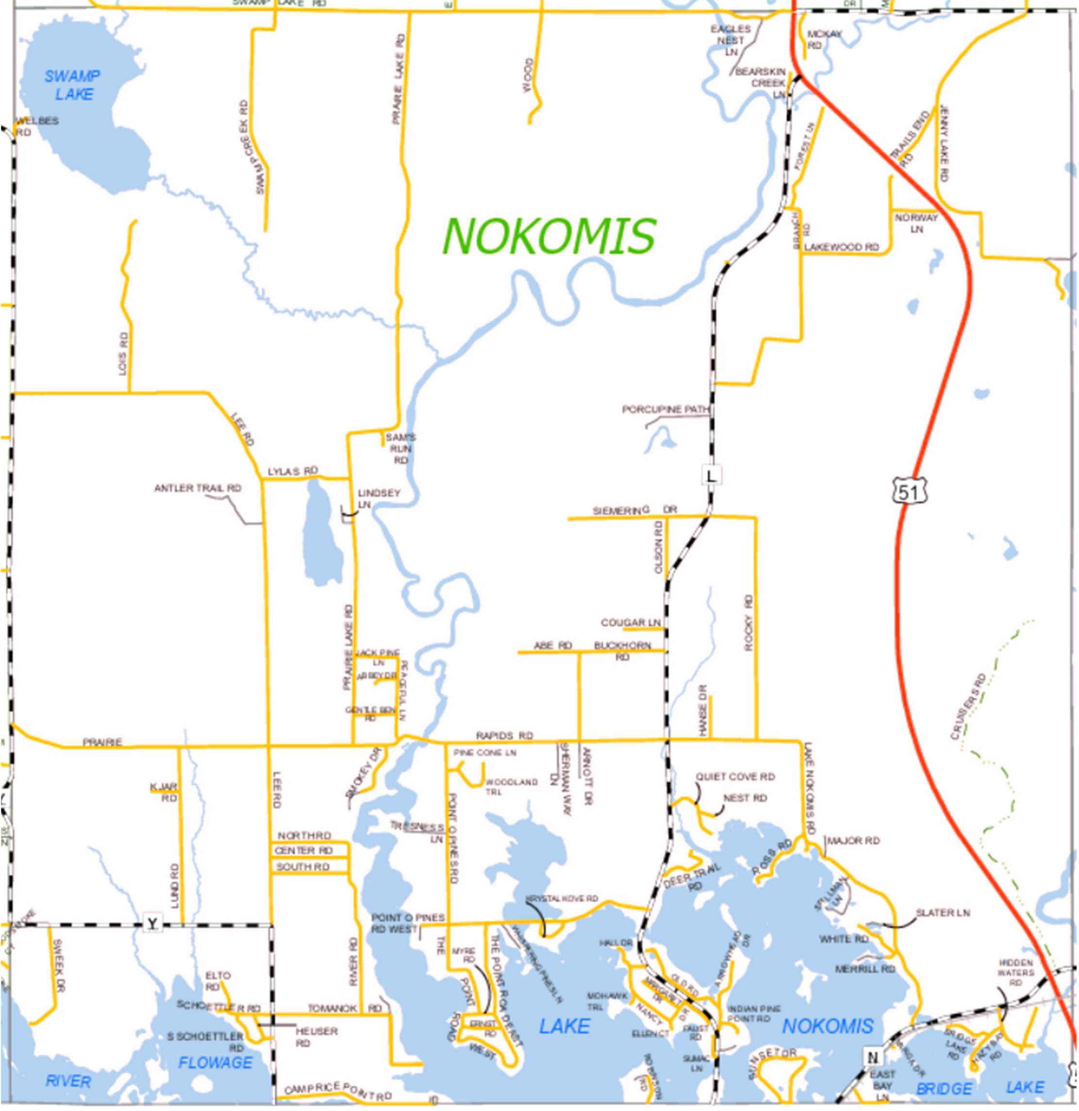
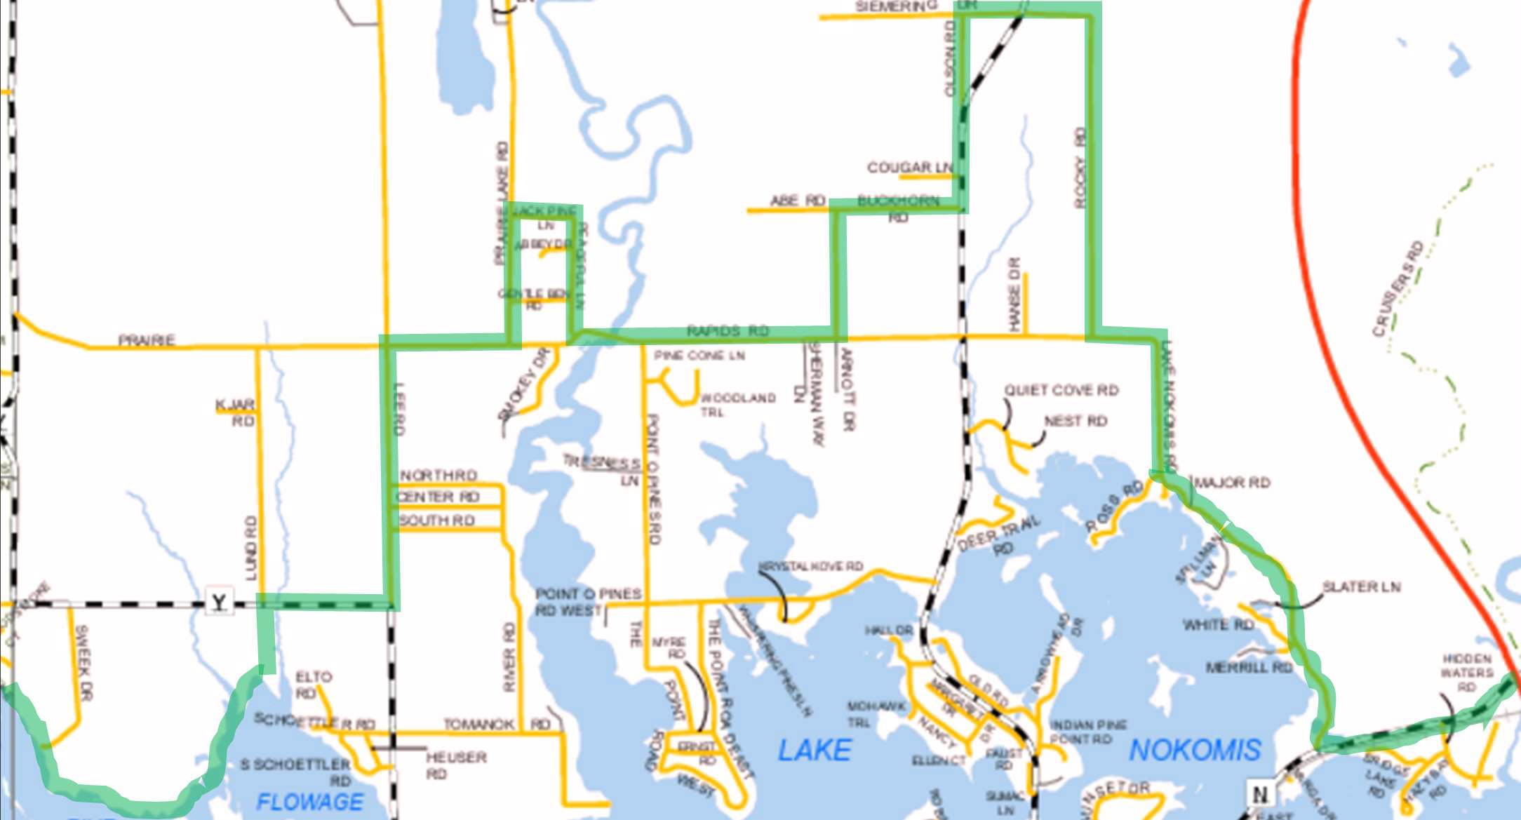

Town of
NOKOMIS

“AREA B”
5.17 acre Lot Min.

“AREA A”
2.87 acre Lot Min.

The Town of Nokomis Map above is divided into two sections: “Area A” with a minimum lot size of 2.87 acres and “Area B” with a minimum lot size of 5.17 acres. The bold green line depicts the boundary line between “Area A” and “Area B”.

SECTION 14
SUBDIVISION/LAND DIVISION DESIGN STANDARDS –
- The subdivider shall conform to the following principles and standards of land subdivision in the design of each subdivision portion thereof:

  - General - The subdivision plan shall conform to design standards that will encourage good development patterns. The streets, drainage rights-of-way, public parks, playgrounds, and other public facilities shown on the adopted Land Use Plan or Official Map shall be considered in the approval of subdivision plats.
  - Land Suitability - No land shall be subdivided for residential use which is held unsuitable for such use as determined by the Town Board for reason of flooding, inadequate drainage, adverse soil or rock formation, unfavorable topography or any other feature likely to be harmful to the health, safety or welfare of the future residents of the proposed subdivision or of the Town. The Town Board may require review of the submittal materials by Oneida County Planning and Zoning. The Town Board shall recite, in writing, the particular facts upon which it bases its conclusion that the land is not suitable for residential use and afford the subdivider an opportunity, if desired, to present evidence regarding such unsuitability. Following such action, the Town Board may affirm, modify, or withdraw its determination of unsuitability.

Roads and Streets -
    - All right-of-way widths shall conform to the following minimum dimensions:
Public Street Type Right of Way Width
Arterial Street 80-100 feet
Town Road 66 feet
Collector Street 66 feet
Cul-de-sac Street 66 feet
Expressway Governed by State
Half Streets Not Permitted

Private Roads and Easements
Right of Way width shall be 66 feet Roadway width shall be 26 feet Surface width shall be 20 Feet
Surface shall have a minimum 6” gravel base Maximum grade of 10%

    - The street layout shall provide access to all lots and parcels of land within the subdivision.
    - Materials cleared and grubbed from the street right-of-way shall not be used for fill or base construction on any streets.
    - Street jogs with centerline offsets of less than one hundred and twenty-five feet shall be avoided.
    - Town roads shall be designed so as to encourage through-traffic. Cul-de-sacs shall not exceed six hundred feet in length unless waived by separate motion by the Town Board as part of the approval of the preliminary plat. Cul-de-sac streets shall terminate in a circular right-of-way with a minimum diameter of one hundred-fifty feet (150') or as determined by the Town Board.

    - Subject to the County Highway Commissioner, the maximum centerline grade of any street or road shall not exceed the following:
Street Type | Maximum Grade
Expressway | Governed by State or Federal Highway Agency
Arterial Street | 10%
Collector Street | 10%
Town Road | 12%
Cul-de-Sac Street | 12%
Private Roads | 10%
    - In situations where subdivision proposals require adjoining or including existing streets that do not conform to the required widths, the subdivider will be required to comply with current road specifications or absorb all costs to modify the existing streets in a safe manner as approved by the Town Board.
    - Streets shall be laid out to intersect at right angles.
    - Intersection of more than two streets at one point shall be prohibited.
    - No street shall have a name which will duplicate or so nearly duplicate any Town or County name as to be confused with the name of an existing street, unless the proposed street is an extension of an existing street, in which case the duplication shall be mandatory.
    - Alleys shall be prohibited in residential areas.

SECTION 15
REQUIRED IMPROVEMENTS –
- Required Improvements for Roads and Streets – Prior to subdividing and road construction, a surety bond may be required to be submitted to the Town Clerk in the amount of 50% of the estimated costs of improvements. Plans for all required improvements shall be submitted to the Town Board for approval at least thirty days prior to the commencement of the construction of such improvements.
- Survey Monuments - subdivider shall install survey monuments placed in accordance with the requirements of Wisconsin Statute §236.15 and as may be required by the Town Board.
- Streets - The subdivider shall be responsible for the installation and cost of all streets within the limits of the land to be subdivided. All streets shall be provided with right-of-way and pavement widths in accordance with Appendix C-l.
- Driveway Culverts - Driveway culverts shall be the responsibility of the subdivider and/or land owners.
- Excavation and Base Construction - The subdivider shall grade the full width of the right-of-way and excavate the roadway to subgrade. The subdivider shall provide a minimum of seven (7) inches of base course construction in the roadway. Excavation and base construction shall comply to the standards established by the Town Board in Appendix C-2.
- Subgrade - The subdivider shall provide plans and excavate to an approved depth so as to provide an adequate subgrade for future roadways. These plans shall be required and approved by the Town Board as part of the preliminary plat.

- Pavement - The subdivider shall provide a minimum of three (3) inches compacted pavement or more as required by the Town Board and shall comply to standards as established by the Town Board in Appendix C-2.
NOTE: Pavement must be completed within 2 years of Town approval of the subdivision plat. Failure to meet this completion requirement will result in fines as outlined in the Town fee schedule. With good cause this requirement may be extended at the discretion of the Town Board.
- Water – The Town does not provide a public water system. Subdividers or private lot owners are responsible for their own private wells as required and approved by the State of Wisconsin and shall be installed prior to occupancy.
- Sanitary Sewer - The Town does not provide a public sanitary sewer system. Subdividers or private lot owners are responsible for their own private sanitary sewage disposal system as required and approved by the State of Wisconsin and shall be installed prior to occupancy.

- Storm Drainage and Storm Sewer - The subdivider shall construct storm water drainage facilities adequate to serve the subdivision which will be in accordance with the State of Wisconsin and Oneida County. All costs shall be the responsibility of the subdivider.

SECTION 16
BUILDING PERMITS –
- No building permit shall be issued by the governing official for the construction of any building, structure, or improvement to the land or any lot within a subdivision as defined herein which has been approved for platting or re-platting until all requirements of this Ordinance and other pertinent ordinances have been fully complied with.

SECTION 18

ENFORCEMENT –
- No plat, CSM, or survey map of any subdivision shall be entitled to be recorded in the County Register of Deeds Office or have any validity until it has been approved in the manner prescribed in this Ordinance.

SECTION 19
RECORD OF PLATS, CSMS, OR SURVEY MAPS –
- All such plats, CSMs, or survey maps of subdivision, after the same have been submitted and approved as provided in this Ordinance, shall be filed and kept by the Town.

SECTION 20 VALIDITY –
- If any title, article, section, clause, paragraph, provision or portion of this Ordinance shall be held to be invalid or unconstitutional by any court of competent jurisdiction, such decision shall not affect any other title, article, clause, paragraph, provision or portion of this Ordinance.

SECTION 21
APPLICATION FEES –
- Preliminary Plat: A preliminary plat review fee shall be paid by the subdivider to the Town at the time of filing the preliminary plat with the office of the Town Clerk. This fee shall be paid again for resubmittals if required by Section 9.
- Final Plat: A final plat review fee shall be paid by the subdivider to the Town at the time of filing the final plat with the office of the Town Clerk.
- Refer to Town of Nokomis Fee Schedule for applicable fees.
- Any other costs incurred by the Town for the approval of improvement plans and/or inspecting during the course of construction shall be paid by the subdivider.

SECTION 22
VIOLATION OR PENALTY –
- Any person, partnership, corporation, or other legal entity that fails to comply with the provisions of this ordinance shall, upon conviction, forfeit applicable fees as described in the Town of Nokomis fee schedule, plus any additional applicable costs incurred by the Town for each offense. Each day a violation exists or continues shall constitute a separate offense.
- Any subdivider or the subdivider’s agent who offers or contracts to sell, or sells any subdivision, lot or parcel knowing that the final plat thereof has not been recorded may be fined applicable fees as described in the Town of Nokomis fee schedule, plus any additional applicable costs incurred by the Town for each offense, except where the preliminary or final plat of the subdivision has been filed for approval with the town or municipality in which the subdivision lies, an offer or contract to convey may be made if that offer or contract states on its face that it is contingent upon approval of the final plat and shall be void if such plat is not approved.

Whenever any violation has occurred, and penalty fees have not been paid, the town attorney shall prosecute as provided by law.

SECTION 23
PUBLICATION AND EFFECTIVE DATE –
1. This Ordinance shall be in full force and effect from and after its passage and publication as provided by law.
TOWN OF NOKOMIS BOARD OF SUPERVISORS

Nate Gaedtke, Town Chairman

Bette Stillman, Town Supervisor

Cheyann Wilke, Town Supervisor
ATTEST:

Wendy Smith, Town Clerk

NOKOMIS LAND DIVISION AND SUBDIVISION

Appendix C-1

Private Road

*NOTE: USE 3.5:1 SLOPE FOR PIPE DIAMETERS LARGER THAN 15”
RURAL CROSS SECTION





*NOTE: NO MATERIAL FROM CLEANING OR GRUBBING SHALL BE USED FOR BASE CONSTRUCTION OR FILL WITHIN THE RIGHT OF WAY
RIGHT-OF-WAY (33 ft minimum)

4 FT SHOULDER
18 FT GRASS DITCH
(WIDOT #40 MIX)
DITCH 2 FT DEEP
6’ TOPSOIL
7FT
EQUAL TO
CENTERLINE
12” GCMP
2.0% SUBGRADE
4.0:1
*3.5:1
18” GCMP
2.0%
11 FT PAVEMENT
TYPICAL DRIVEWAY SLOPE
2% - 3%


RIGHT-OF-WAY
CL ROADWAY

NOKOMIS LAND DIVISION AND SUBDIVISION

Appendix С-2

EXCAVATION AND BASE CONSTRUCTION
All streets 7 inches thick
Additional thickness may be required depending on traffic and soil conditions
Subdivider must provide a fully loaded tri-axel dump truck for proof rolling subgrade prior to base course placement
Proof rolling will be witnessed by a Town Representative

*NOTE: No material from cleaning or grubbing shall be used for base construction or fill within the right-of-way

CURB AND GUTTER SPECIFICATIONS
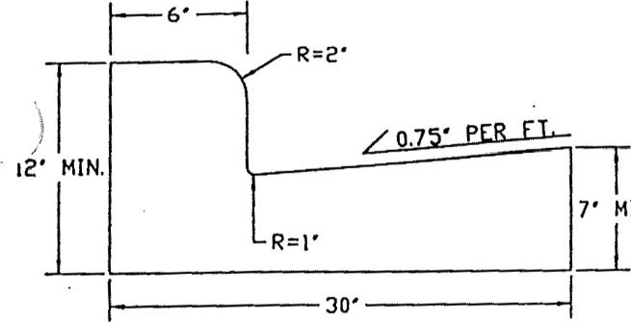
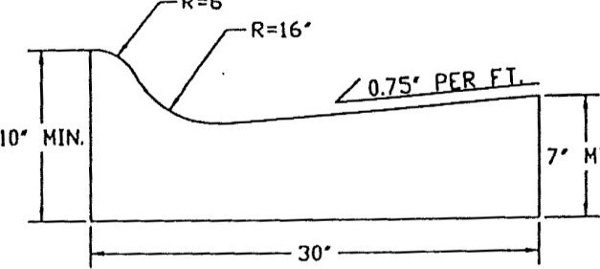


Standard “D” Type: curb and gutter
Roll back curb and gutter (When approved by Town)

PAVEMENT SPECIFICATIONS

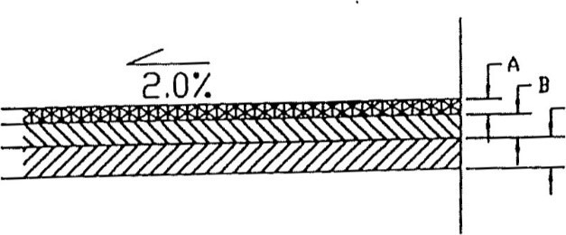
C

STREET TYPE THICKNESS
ALL 3.0 inches
Additional thickness may be required depending on traffic and soil conditions.
TOTAL PAVEMENT THICKNESS 3.0”
- Surface course 3.0”
- WIDOT Grade 2 crushed stone 3.0”
- WIDOT Grade 1 crushed stone 4.0” Half of the full depth with each grade

