PLEASE CONTACT YOUR TOWN FOR POSSIBLE DRIVEWAY PERMIT AND/OR FEES

**Town of Nokomis Address Application**

**Return to your Town with appropriate fee**

Office use only

|  |  |  |  |  |  |  |  |  |  |  |  |
| --- | --- | --- | --- | --- | --- | --- | --- | --- | --- | --- | --- |
|  | Building Site |  | Municipal Township |  | | | |  | |  |  |
|  | Existing Dwelling |  | Driveway Permits Required? | | Yes | No | Permit# | |  | | |

# Contact Information

|  |  |  |  |  |  |  |  |  |  |  |  |  |  |  |
| --- | --- | --- | --- | --- | --- | --- | --- | --- | --- | --- | --- | --- | --- | --- |
| Applicants name | | | |  | | | | Phone | |  | | | | |
| Address | |  | | | | City |  | | State | |  | Zip |  |
| Email |  | | | | | | | Fax | |  | | | |
| Landowners name | | | | |  | | | Phone | |  | | | |
| Address | | |  | | | City |  | | State | |  | Zip |  |

# Driveway Information

|  |  |  |  |  |  |  |  |  |  |  |  |  |  |  |  |  |  |
| --- | --- | --- | --- | --- | --- | --- | --- | --- | --- | --- | --- | --- | --- | --- | --- | --- | --- |
| Tax Parcel # | | |  | | | | Road name | |  | | | | | | | | Side of Road N S E W |
| Section |  | Town | | |  | Range | |  | | Forty or GL # | | | |  | |
| Subdivision name | | | |  | | | | | | | Lot |  | Block | |  |

**IMPORTANT - If any of the information contained on this form is found to be inaccurate, you may be required to change your address at the time of the discovery. The information presented below is accurate to the best of my knowledge.**

You must indicate the address and ***accurate distance*, each way, from your driveway to the nearest neighbors’ driveways**. The neighbors can be across the road as long as the closest neighbors are used. Please indicate if you share a driveway with others.

|  |  |  |  |  |  |
| --- | --- | --- | --- | --- | --- |
| Neighbor 1 address |  | Distance |  | Direction |  |
| Neighbor 2 address |  | Distance |  | Direction |  |
| Nearest intersection 1 |  | Distance |  | Direction |  |
| Nearest intersection 2 |  | Distance |  | Direction |  |

### Sketch

Name Printed Signature Date

**Office Use Only**

|  |  |  |  |
| --- | --- | --- | --- |
| Received by |  | Date |  |
| Address Assigned |  | By |  | Date |  |
| Verified by |  | Date |  | Address Compliant? Yes No | |

**PePermit Fees and Requirements**

Nokomis Driveway Permit $175.00

Address Sign Installation $75.00

After The Fact Permit $675.00

Culverts may be required to be installed by owner at a future date due to road surface improvements.

Applicant will receive and must follow a copy of the Nokomis subdivision ordinance pertaining to driveway and address installations. Signature below acknowledges receipt of the ordinance.

The information on this form is accurate to the best of my knowledge.

Applicant Signature____________________________________ Application Date_________________

### Town of Nokomis Office Use

#### Date Paid____________ Check_____ Cash_____ Received By______________________________

#### Culvert required? Yes_____ No_____ Diameter__________(inches) Length____________(feet)

#### Location and Date Approved_____________________ By___________________________________

#### Final Inspection Date_______________________ By _______________________________________

**Permit # _______________** Revised 10/

**Instructions**

**Contact Information**

1. *Applicants* – Provide your name, present phone, fax, email and address information.

2. *Land* *Owners* –Provide the owners name, phone and address information if it differs from the applicant’s info.

**Driveway Information** (most of the following information can be obtained from your tax bill)

1. *Pin#* - Provide the parcel identification number shown on your tax bill for the parcel of land containing the intersection of the driveway and the road.
2. *Road name, Side of road* – Provide the Road name and circle the side of the road that the driveway is on.
3. *Section, Town, Range, Forty or GL#* – Provide the section, township, range and forty or GL# (i.e. NWSE, GL3, etc.) that the driveway/road intersection is located.
4. *Subdivision Plat Name, Lot and Block* – Specify the lot, block and subdivision name of the driveway parcel, if applicable and indicated on your tax bill.
5. *Neighbors*– Provide the addresses, distances and directions to the two nearest neighbors’ driveways **on either side of the road** OR
6. *Intersection-if closer than a neighbor,* measured along the road, **in both directions** use either neighbors or intersections **WHICHEVER IS CLOSEST**.

**Building Information**

1. *Building type* – Provide the building type for building receiving the address with this application (house, commercial building, etc...).
2. It is only necessary to fill out the other lines in this section if the information is different from the information for the driveway.

**Sketch** – Please draw a sketch of the location of your driveway as accurately as possible. This sketch should show the following items:

1. Show the distances between your driveway and you neighbors’ driveways or road intersections.
2. Driveway information -see sample sketch below. Make sure your distances are accurate to the nearest 10’
3. Miscellaneous information – Must have the compass shown with directions, any other explanatory text that would be helpful, etc...)

**Sample Sketch**

90’

’’

90’

1295

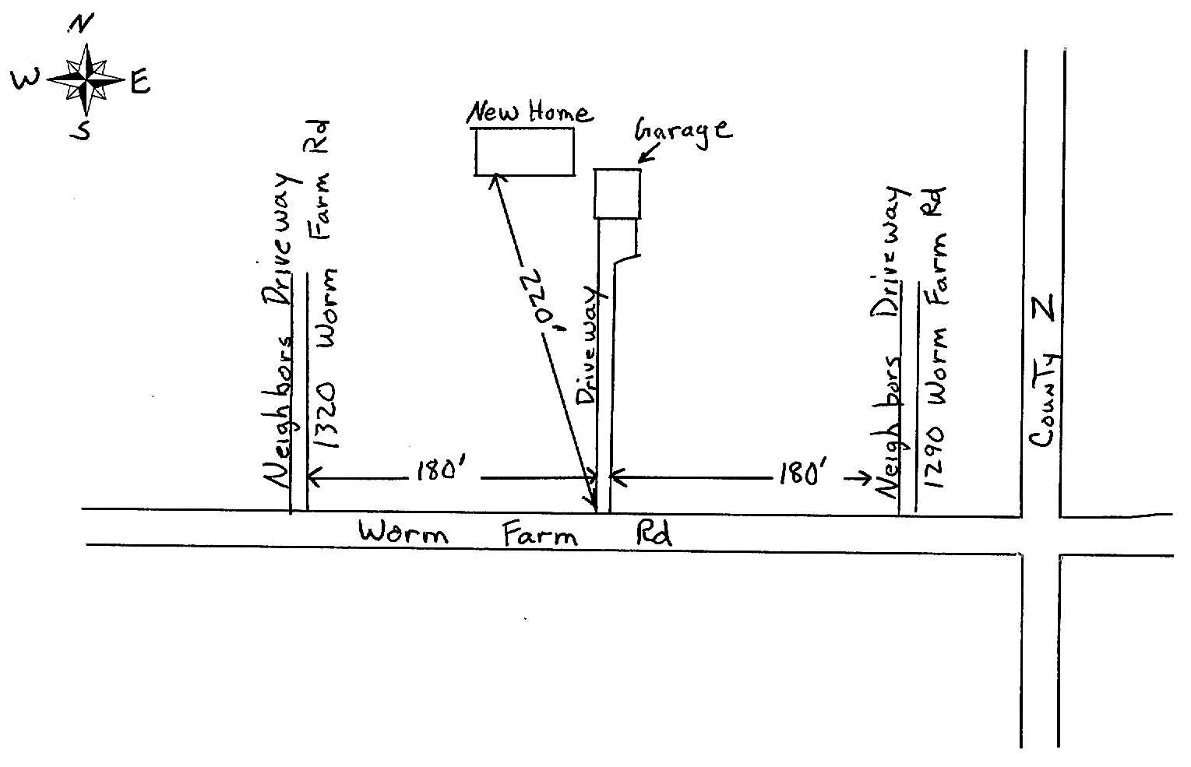

##### DRAW SKETCH BELOW



## Oneida County Office Use Only

Received by_____________________________ Date_____

Address Assigned_______________________________ By________________ Date__________

Field Verified by______________ Date_______ Address Compliant? Yes No